Time for Young Female University Students Leaders in Kenya
By George Kaggwa
When Immaculate Masinde was elected the Chairlady of Tangaza Students Association (TANSA) in April, many read it as a major paradigm shift in University students’ leadership. This is became her election came hot in the heels of the election of Anne Mwangi Mvurya as the first ever female student leader at the University of Nairobi’s history.
Immaculate who is a BA in Leadership and Management student at Tangaza University College starts by first congratulating her senior counterpart Anne Mwangi Mvurya and wishes her the best now that she has cleared her first huddle when her election that had been earlier contested was up-held. She disagrees with the popular belief that a victory for a young female leader is a win for women. She borrows from Tom Peters who said that ‘true leaders do not create followers but instead create leaders’.
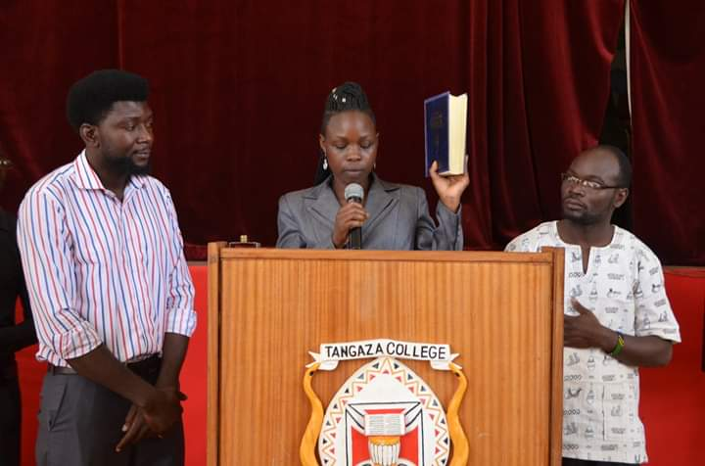
Immaculate Masinde takes her oath of office as the new TANSA President

Immaculate who is moving into her final year in college attributes her victory to the support and encouragement she received especially from the male students. She says the male comrades were ready to have a leader from the opposite gender by looking beyond the skirt. “I owe my brothers in college a great thank you for encouraging and pushing me to fight for my dreams” she said.
Asked how she hopes to fare in a position that has traditionally been occupied by male students, Immaculate was quick to say that she personally believe that women leadership is not just an achievement to the female gender at the campus, but quipped that it was equally demanding because, as women, she will be expected to work on overdrive to prove that she is worth the position despite being a woman. It is a challenge she will live with throughout her leadership because as a trailblazer, she wants to pave way for election of more female student leaders in future, by leaving no trail of doubt in the minds of students by demonstrating what female students’ leadership can be made of.
“Female and male students alike look up to me to deliver so that in future another woman may be given a chance like mine, based on my success story” Immaculate Masinde.
Immaculate, who hails from Nasianda village, Likuyani constituency of Kakamega County, believes that in student politics, it should not be the amount of money that one spends in campaigns that should propel one to leadership, but merit. When students spend millions in campaigns and end up losing, they never believe it and this could be one reason why they contesting results. “This mentality of buying voters must end”, she argues. Student politics should be free from violence and political interference as witnessed in other Universities. She welcomes the recent initiative by the majority leader in the Kenyan Parliament to limit the amount of funds used in campaigns.
Leadership Style
As a Leadership and Management student at Tangaza University College, Immaculate believes in leadership that is participatory and transformative. “Students should get involved in the decisions we make as student leaders” she argues, saying that this increases trust in leadership. Immaculate does not forget the inspiration she got from her own mother who has served as a Chairlady of an organization in Nairobi. The mother’s leadership styles involves people and Immaculate believes things can be done her mother’s way.
In what appears to be a departure from many proponents of women leadership and empowerment, Immaculate believes that the days of affirmative action is long gone. “Women leader should no longer be favored or nominated into leadership positions but they should fight for it …you will not value what you are given freely” she argued, saying that female students aspiring to be leaders should believe in themselves and go for it by voicing what is in them. “Anne Mvurya and I made it why can’t you” she concludes.
George Kaggwa is a lecturer at Tangaza University College and Chairman of the Youth Workers Association, Kenya. gkaggwa106@gmail.com
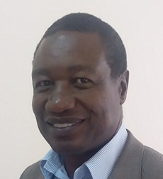
George Kaggwa

